installation/backup instructions

1. Installation

To install .bak file, firstly right click Database --> Restore Database...

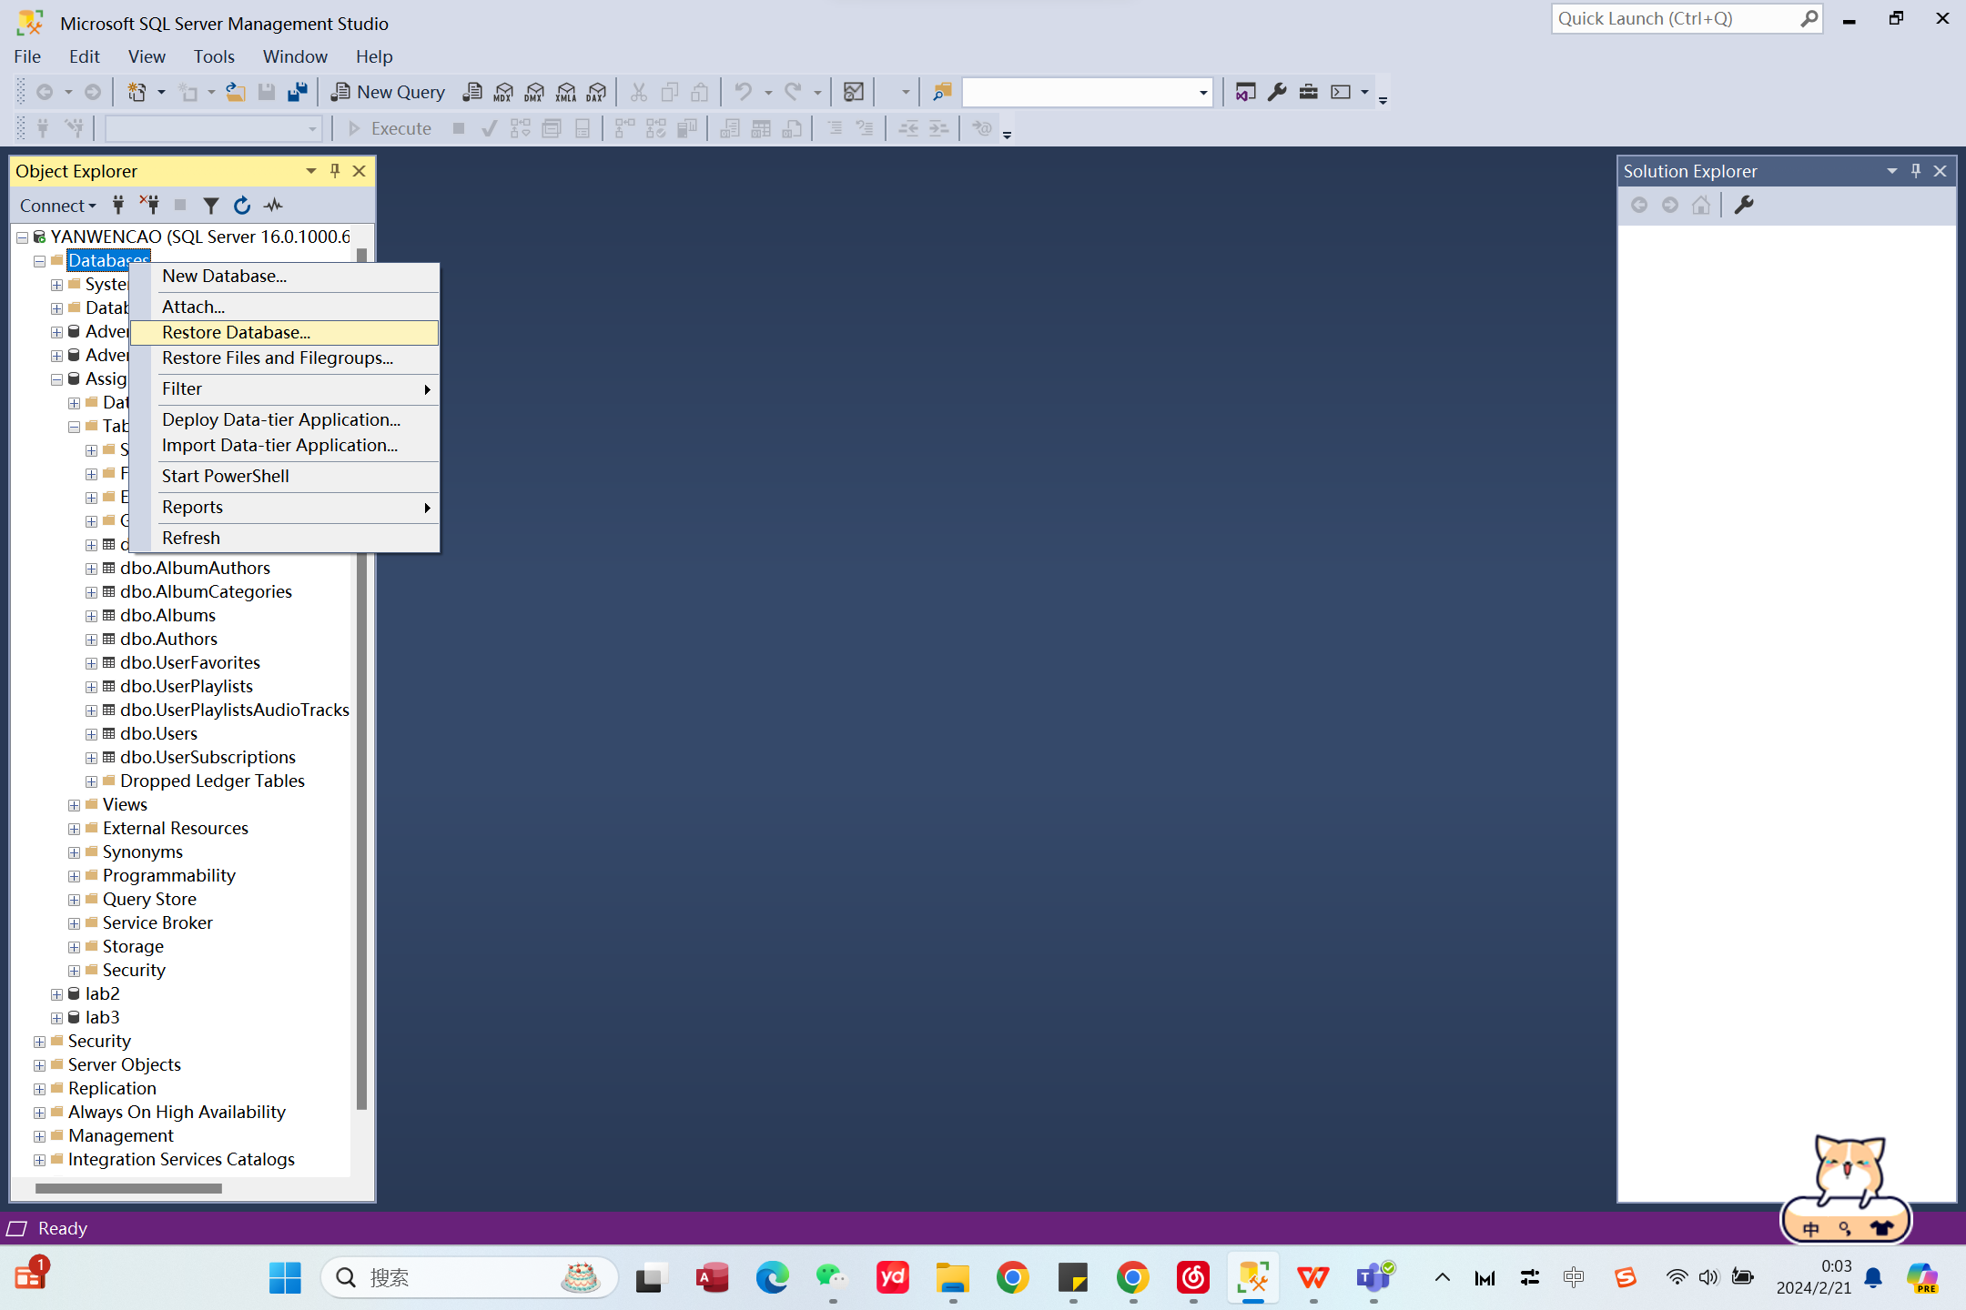

As following picture, chose the target .bak file.

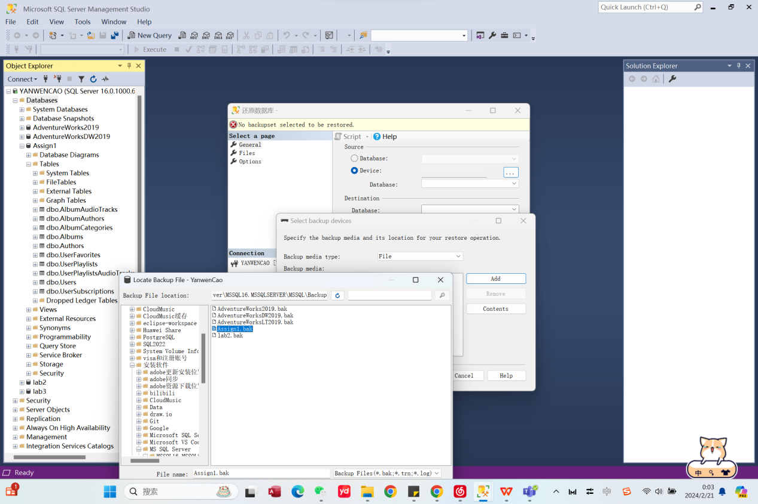

1. Backup

To backup database, firstly right click target database, in this case use: Assignment1 --> Tasks -->backup, tick “Copy-only backup”, then click OK.

